|  |  |
| --- | --- |
| Date | 24 October 2022 |
| Team ID | PNT2022TMID36762 |
| Project Name | Gas Leakage Monitoring and Alerting System |

MILESTONE

Project Development Phase

(Sprint 4)

M

Project Design and Planning

(Project Planning Phase)

Project Development Phase

(Sprint 3)

Project Design and Planning

(Project Design Phase 2)

Project Development Phase

(Sprint 2)

Project Design and Planning

(Project Design Phase 1)

Project Development Phase

(Sprint 1)

Project Design and Planning

(Ideation Phase)

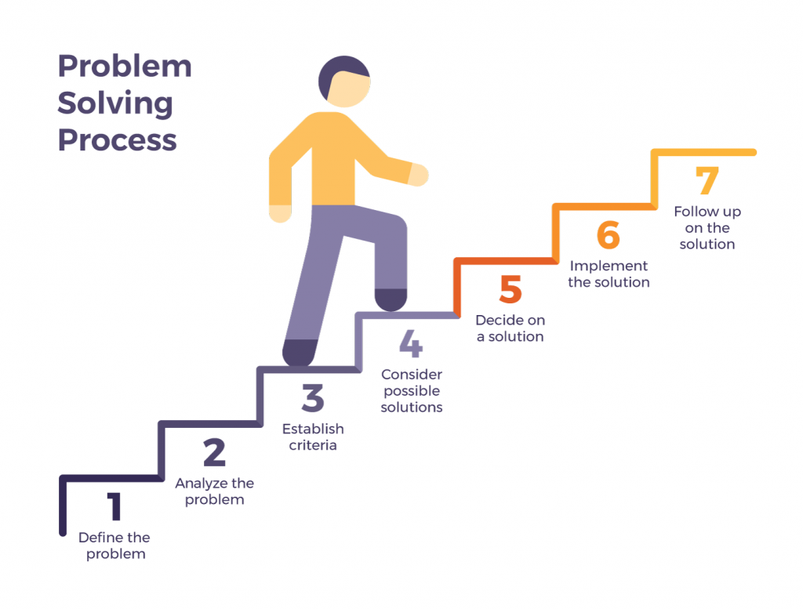

**8**